Name ___________________________________________________________________ Date _________

Thermal Energy Study Guide (20 Points)

My Test is on _______________________________________________

|  |  |  |
| --- | --- | --- |
| *1) Thermal energy*  *2) Heat*  *3) Conduction*  *4) radiation*  *5) convection*  *6.) Convection Current* | *6) Specific Heat*  *7) gas*  *8) liquid*  *9)solid*  *10.) contract* | *11) thermal expansion*  *12.) Law of conservation of energy*  *13.) Temperature* |

Complete each statement with a vocabulary word. You may use a word more than one time

1. The total energy ( kinetic and potential of all the particles in a substance is called ______________________________.
2. The movement of thermal energy from a warmer object to a cooler object is called _______________________________.
3. Heat is transferred from one particle of matter to another without the movement of matter itself in a process called ____________________________________.
4. The transfer of energy by electromagnetic waves is called ____________________________.
5. The amount of energy required to raise the temperature of 1 kilogram of a substance by 1 kelvin is called its ______________________ ______________________.
6. The forms, or states of matter are _________________________ ________________________ _____________________________
7. ________________________ has no definite shape but has a definite volume.
8. The expanding of matter when it is heated is known as _____________________________.
9. Heated air moves from baseboard heaters to the rest of a room in a process called ___________________________________________.
10. A measure of the average kinetic energy of the individual particles in an object is called _______________________________________________.
11. In an effort to reduce a school’s environmental impact, a school board is planning to install solar panels on the roof to collect sunlight.

What is the energy conversion performed by these panels?

|  |  |
| --- | --- |
| a. | Sound energy is converted to electrical energy |
| b. | Light energy is converted into electrical energy |
| c. | Heat energy is converted into light energy |
| d. | Electrical energy is converted into sound energy |
|  |  |

Using a Diagram

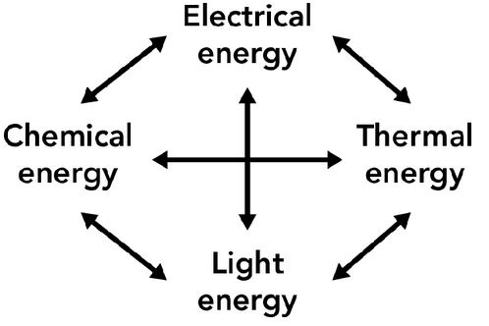The diagram below shows the possible energy transformations that can occur when energy is generated to do work

14. There are 3 energy transformations that take place when a light is turned on. What are they?

1. ______________________________________________

2. ______________________________________________

3. ______________________________________________

1. **What energy transformation(s) takes place when you place a pot on a stove and boil a pot of water?**
2. . Describe how the Law of Conservation of Energy relates to the diagram. Give an example to support your description